**Core Business Subsystem for a Ticket Booking System**

1.1 Refund Request Submission Function

Function ID: FR-01

Description: The user can submit a refund request for a previously placed order.

Input: Order ID, refund reason, and optional supporting documents.

Output: Refund request record stored in the system with initial status "pending."

1.2 Order Validation Function

Function ID: FR-02

Description: The system checks if the associated order exists and is in a valid state (e.g., completed or partially fulfilled) for refund processing.

Input: Refund request record containing the Order ID.

Output: Validation result indicating whether the order is valid for refund.

1.3 Refund Request Review Function

Function ID: FR-03

Description: The administrator can review refund requests and assess the eligibility for processing.

Input: Refund request record with Order ID and user-submitted reason.

Output: Review result with eligibility status and optional comments.

1.4 Refund Approval Function

Function ID: FR-04

Description: The administrator can approve a refund request if it is eligible.

Input: Refund request record and review result.

Output: Refund status updated to "approved" and a flag to initiate the refund process.

1.5 Refund Denial Function

Function ID: FR-05

Description: The administrator can deny a refund request if it is not eligible.

Input: Refund request record and review result.

Output: Refund status updated to "denied" and a reason for denial stored in the system.

1.6 Refund Process Initiation Function

Function ID: FR-06

Description: The system initiates the refund process with the payment gateway when a refund request is approved.

Input: Approved refund request and associated payment details.

Output: Refund transaction initiated and status updated in the system.

1.7 User Notification Function (Refund Approval)

Function ID: FR-07

Description: The system sends a confirmation message to the user when the refund is approved.

Input: Approved refund status and user contact information.

Output: Notification message sent to the user (e.g., via email or in-app).

1.8 User Notification Function (Refund Denial)

Function ID: FR-08

Description: The system sends a denial message to the user when the refund is not approved.

Input: Denied refund status and the reason for denial.

Output: Notification message sent to the user (e.g., via email or in-app).

1.9 Order Status Update Function (Refund Approved)

Function ID: FR-09

Description: The system updates the order status to reflect the approved refund.

Input: Approved refund status and related order ID.

Output: Order status updated to "refunded" or "partially refunded."

1.10 Order Status Update Function (Refund Denied)

Function ID: FR-10

Description: The system updates the order status to remain unchanged when a refund request is denied.

Input: Denied refund status and related order ID.

Output: Order status remains the same as before the refund request was submitted.

1.11 Refund Tracking Function

Function ID: FR-11

Description: The system allows the administrator to track the status of a refund request.

Input: Refund request ID or order ID.

Output: Current refund status and history of actions taken.

1.12 Refund Amount Calculation Function

Function ID: FR-12

Description: The system calculates the eligible refund amount based on the order details and refund policy.

Input: Order details, refund policy rules, and refund request.

Output: Calculated refund amount to be processed.

1.13 Refund Policy Enforcement Function

Function ID: FR-13

Description: The system enforces the refund policy to determine if the refund request is valid.

Input: Refund request, order details, and refund policy rules.

Output: Policy validation result indicating whether the request meets the criteria.

1.14 Refund Request Logging Function

Function ID: FR-14

Description: The system logs all refund requests and related actions for auditing and record-keeping.

Input: Refund request details and system-generated timestamps.

Output: Log entry stored in the system with relevant information.

1.15 Refund Request Search Function

Function ID: FR-15

Description: The system allows the administrator to search for refund requests based on criteria such as order ID, user ID, or refund status.

Input: Search criteria (e.g., order ID, user ID, refund status).

Output: List of matching refund requests displayed to the administrator.

1.16 Refund Request Summary Reporting Function

Function ID: FR-16

Description: The system generates summary reports of all refund requests processed within a specified time period.

Input: Start and end date for the report.

Output: Summary report including number of requests, approval/denial rates, and total refund amounts.

1.17 Refund Transaction History Function

Function ID: FR-17

Description: The system maintains a history of all refund transactions for reference and auditing.

Input: Refund transaction details and timestamps.

Output: Transaction history record stored in the system.

1.18 Refund Status Monitoring Function

Function ID: FR-18

Description: The system provides a dashboard for administrators to monitor the current status of all refund requests.

Input: Administrator login credentials and system access.

Output: Dashboard view with real-time refund status and key metrics.

1.19 Refund Request Cancellation Function

Function ID: FR-19

Description: The system allows users to cancel a refund request before it is processed.

Input: Refund request ID and user authentication.

Output: Refund request status updated to "cancelled."

1.20 Refund Request Reassignment Function

Function ID: FR-20

Description: The system allows administrators to reassign a refund request to another administrator for review.

Input: Refund request ID, target administrator ID, and reason for reassignment.

Output: Refund request ownership updated and notification sent to the new administrator.

1.21 Refund Request Escalation Function

Function ID: FR-21

Description: The system escalates a refund request to a higher-level administrator if the initial reviewer is unable to make a decision.

Input: Refund request ID, reason for escalation, and current reviewer status.

Output: Refund request escalated and status updated accordingly.

1.22 Refund Request Resolution Time Tracking Function

Function ID: FR-22

Description: The system tracks the time taken to resolve each refund request.

Input: Refund request submission and resolution timestamps.

Output: Resolution time stored and displayed for performance monitoring.

1.23 Refund Policy Rule Configuration Function

Function ID: FR-23

Description: The system allows administrators to configure refund policy rules.

Input: Refund policy parameters (e.g., time limits, percentage to refund, conditions).

Output: Updated refund policy rules stored in the system.

1.24 Refund Request History Retrieval Function

Function ID: FR-24

Description: The system allows users and administrators to retrieve the history of a specific refund request.

Input: Refund request ID or user ID.

Output: Detailed history of the refund request, including status changes and comments.

1.25 Refund Status Change Notification Function

Function ID: FR-25

Description: The system automatically notifies the user when the refund request status changes.

Input: Refund status change event and user contact information.

Output: Notification message sent to the user (e.g., via email or SMS).

1.26 Refund Policy Rule Validation Function

Function ID: FR-26

Description: The system validates the refund policy rules to ensure they are logically consistent and applicable.

Input: Proposed refund policy rules and existing system data.

Output: Validation result indicating whether the rules are valid and ready for implementation.

1.27 Refund Request Assignment Function

Function ID: FR-27

Description: The system assigns new refund requests to an administrator for processing.

Input: Refund request record and available administrator list.

Output: Refund request assigned to a specific administrator with status updated.

1.28 Refund Request Filtering Function

Function ID: FR-28

Description: The system allows administrators to filter refund requests by status, date, or other relevant criteria.

Input: Filter criteria (e.g., status, date range, refund amount).

Output: List of filtered refund requests displayed to the administrator.

1.29 Refund Request Detail Display Function

Function ID: FR-29

Description: The system displays the detailed information of a selected refund request to the administrator.

Input: Refund request ID.

Output: Refund request details including user information, order data, and submission reason.

1.30 Refund Request Comment Addition Function

Function ID: FR-30

Description: The system allows the administrator to add comments to a refund request for internal communication.

Input: Refund request ID and comment text.

Output: Comment added to the refund request record for future reference.

1.31 Refund Request Status Update Function

Function ID: FR-31

Description: The system allows the administrator to manually update the refund request status if needed.

Input: Refund request ID and new status.

Output: Refund request status updated in the system.

1.32 Refund Request Archiving Function

Function ID: FR-32

Description: The system archives processed refund requests to reduce clutter in active request lists.

Input: Refund request ID and archival criteria.

Output: Refund request moved to an archive and status updated.

1.33 Refund Request Export Function

Function ID: FR-33

Description: The system allows administrators to export refund request data in CSV or Excel format for external analysis.

Input: Export criteria (e.g., date range, status).

Output: Exported file with refund request details.

1.34 Refund Request Import Function

Function ID: FR-34

Description: The system allows administrators to import bulk refund requests from a file.

Input: CSV or Excel file with refund request details (e.g., order ID, user ID, refund reason).

Output: Multiple refund requests created and stored in the system.

1.35 Refund Request Audit Trail Function

Function ID: FR-35

Description: The system maintains an audit trail of all actions taken on refund requests for compliance and accountability.

Input: User action (e.g., approve, deny, cancel) and associated refund request ID.

Output: Audit record created and stored in the system.

1.36 Refund Request User View Function

Function ID: FR-36

Description: The system allows users to view the status and history of their refund requests.

Input: User login credentials and refund request ID.

Output: Refund request status and history displayed to the user.

1.37 Refund Request Comment Visibility Function

Function ID: FR-37

Description: The system ensures that refund request comments are only visible to authorized users.

Input: Comment record and user access permissions.

Output: Comment displayed or hidden based on user authorization.

1.38 Refund Request Assignment Alert Function

Function ID: FR-38

Description: The system sends an alert to the assigned administrator when a new refund request is received.

Input: Refund request ID and assigned administrator information.

Output: Alert notification sent to the administrator via email or in-app.

1.39 Refund Request Time-to-Process Monitoring Function

Function ID: FR-39

Description: The system monitors the average time taken to process refund requests and generates reports.

Input: Historical refund request data and current system time.

Output: Report on average processing time for refund requests.

1.40 Refund Request Escalation Rule Configuration Function

Function ID: FR-40

Description: The system allows administrators to configure rules for when refund requests should be escalated.

Input: Escalation rule parameters (e.g., time limit, status threshold).

Output: Escalation rules stored and applied to new refund requests.

1.41 Refund Request Status Change Logging Function

Function ID: FR-41

Description: The system logs every status change made to a refund request for traceability.

Input: Refund request ID, previous and new status, and user who made the change.

Output: Status change log entry stored in the system.

1.42 Refund Request Assignment History Function

Function ID: FR-42

Description: The system maintains a history of all administrators who have been assigned to a refund request.

Input: Refund request ID and administrator assignment records.

Output: Assignment history displayed for the refund request.

1.43 Refund Request User Contact Verification Function

Function ID: FR-43

Description: The system verifies the user's contact information before sending refund-related notifications.

Input: User ID and associated contact details.

Output: Verified contact information or error message if unverified.

1.44 Refund Request User Authentication Function

Function ID: FR-44

Description: The system verifies the user's identity when they submit or cancel a refund request.

Input: User login credentials or session token.

Output: Authentication result indicating whether the user is authorized.

1.45 Refund Request Administrator Authentication Function

Function ID: FR-45

Description: The system verifies the administrator's identity when they perform any action on a refund request.

Input: Administrator login credentials or session token.

Output: Authentication result indicating whether the administrator is authorized.

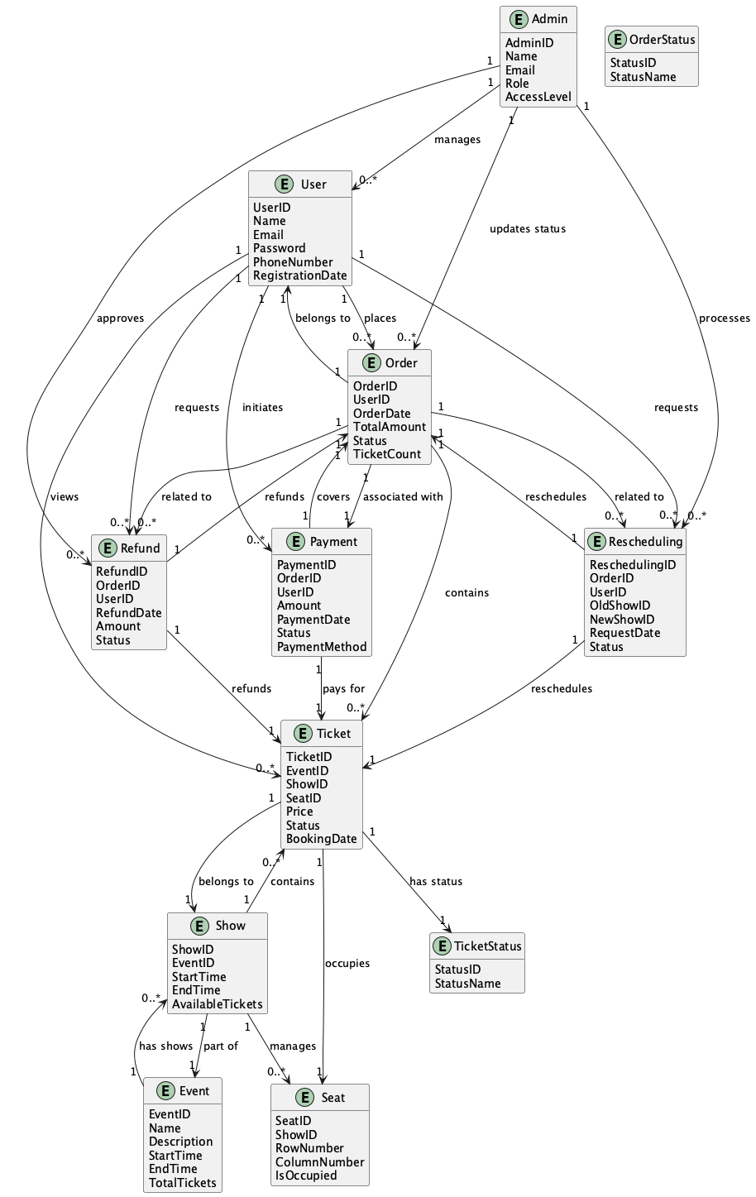

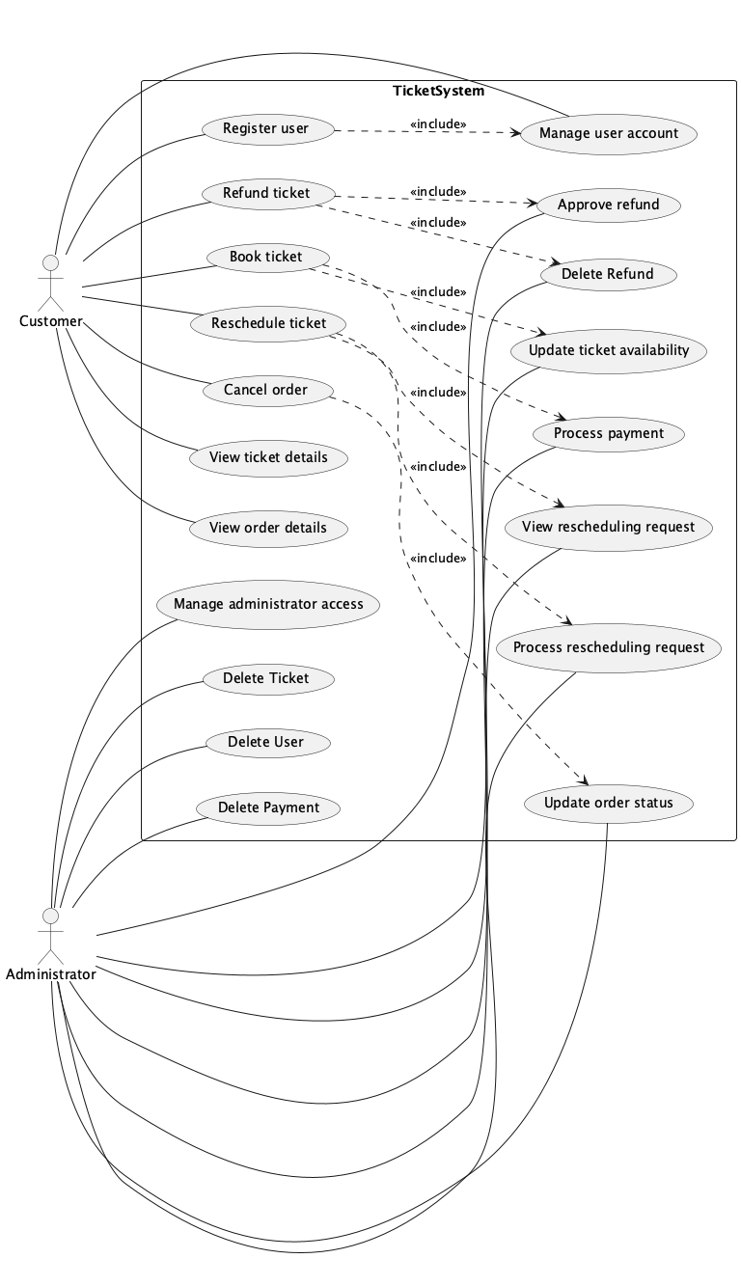

Data Management System

好的，我将为每个用例生成至少两条功能需求，确保总数达到40条以上。以下是详细的功能需求列表：

### 1. Create Database (UC-01)

1.1 Database Creation Function

Function ID: FR-01

Description: Allow administrators to create new databases with specified configurations.

Input: Unique database name and configuration details (e.g., storage size, access permissions).

Output: A new database registered in the system with confirmation to the administrator.

1.2 Database Configuration Validation Function

Function ID: FR-02

Description: Validate the configuration details provided for new database creation.

Input: Database configuration details (e.g., storage size, access permissions).

Output: Validation result indicating whether the configuration is valid or if there are conflicts.

### 2. Maintain Database (UC-02)

1.3 Database Maintenance Function

Function ID: FR-03

Description: Enable administrators to perform maintenance tasks on existing databases.

Input: Selection of target database and maintenance operation (e.g., backup, optimize, repair).

Output: Maintenance activity logged and confirmation of completion to the administrator.

1.4 Database Maintenance Status Function

Function ID: FR-04

Description: Provide status updates on maintenance tasks performed on databases.

Input: Maintenance operation and target database.

Output: Status updates and logs of maintenance activities.

### 3. Backup Data (UC-03)

1.5 Data Backup Function

Function ID: FR-05

Description: Allow administrators to create backups of selected databases.

Input: Selection of database for backup.

Output: Backup record created and stored with activity logged in the Behavior Log.

1.6 Backup Status Notification Function

Function ID: FR-06

Description: Notify administrators of the status of backup operations.

Input: Backup operation request.

Output: Notification of backup completion or failure.

### 4. Recover Data (UC-04)

1.7 Data Recovery Function

Function ID: FR-07

Description: Enable administrators to recover databases from backup records.

Input: Selection of Backup Record for recovery.

Output: Database restored and recovery activity logged in the Behavior Log.

1.8 Recovery Status Notification Function

Function ID: FR-08

Description: Notify administrators of the status of recovery operations.

Input: Recovery operation request.

Output: Notification of recovery completion or failure.

### 5. Analyze Sales Data (UC-05)

1.9 Sales Data Analysis Function

Function ID: FR-09

Description: Provide analysis of sales data based on specified criteria.

Input: Analysis criteria (e.g., time range, product category, sales region).

Output: Analysis results displayed in a report or visualization with activity logged.

1.10 Sales Data Retrieval Function

Function ID: FR-10

Description: Retrieve sales data from the database based on specified criteria.

Input: Analysis criteria (e.g., time range, product category, sales region).

Output: Retrieved sales data ready for analysis.

### 6. Analyze User Behavior (UC-06)

1.11 User Behavior Analysis Function

Function ID: FR-11

Description: Analyze user behavior data based on specified criteria.

Input: Analysis criteria (e.g., time range, user group, activity type).

Output: Analysis results displayed in a report or visualization with activity logged.

1.12 User Behavior Data Retrieval Function

Function ID: FR-12

Description: Retrieve user behavior data from the database based on specified criteria.

Input: Analysis criteria (e.g., time range, user group, activity type).

Output: Retrieved user behavior data ready for analysis.

### 7. Register User (UC-09)

1.13 User Registration Function

Function ID: FR-13

Description: Allow administrators to register new users in the system.

Input: User details (e.g., username, password, role).

Output: New user registered with confirmation and activity logged in the Behavior Log.

1.14 User Registration Validation Function

Function ID: FR-14

Description: Validate user details provided during registration.

Input: User details (e.g., username, password, role).

Output: Validation result indicating whether the details are valid or if there are conflicts.

### 8. Update User Profile (UC-10)

1.15 User Profile Update Function

Function ID: FR-15

Description: Enable users and administrators to update user profiles.

Input: Modified profile fields (e.g., name, email, role).

Output: Updated user profile with confirmation and activity logged in the Behavior Log.

1.16 User Profile Validation Function

Function ID: FR-16

Description: Validate updated user profile information.

Input: Modified profile fields (e.g., name, email, role).

Output: Validation result indicating whether the updated information is valid or if there are conflicts.

### 9. Delete User (UC-11)

1.17 User Deletion Function

Function ID: FR-17

Description: Allow administrators to delete user accounts.

Input: Selection of user to be deleted.

Output: User deleted from the system with confirmation and activity logged in the Behavior Log.

1.18 User Deletion Validation Function

Function ID: FR-18

Description: Validate the user account before deletion.

Input: User ID or selection.

Output: Validation result indicating whether the user can be deleted or if there are constraints.

### 10. Manage Administrator Access (UC-12)

1.19 Administrator Access Management Function

Function ID: FR-19

Description: Enable administrators to manage access rights for other administrators.

Input: Selection of administrator and access action (e.g., grant, modify, revoke).

Output: Updated access rights with confirmation and activity logged in the Behavior Log.

1.20 Administrator Access Validation Function

Function ID: FR-20

Description: Validate access rights changes for administrators.

Input: Access action and target administrator.

Output: Validation result indicating whether the access change is valid or if there are conflicts.

### 11. View Backup Records (UC-13)

1.21 Backup Record Viewing Function

Function ID: FR-21

Description: Allow administrators to view existing backup records.

Input: Request to view backup records.

Output: Displayed backup records with activity logged in the Behavior Log.

1.22 Backup Record Retrieval Function

Function ID: FR-22

Description: Retrieve backup records from the database.

Input: Request to view backup records.

Output: Retrieved backup records ready for display.

### 12. Delete Backup Records (UC-14)

1.23 Backup Record Deletion Function

Function ID: FR-23

Description: Enable administrators to delete backup records.

Input: Selection of backup records to be deleted.

Output: Backup records deleted with confirmation and activity logged in the Behavior Log.

1.24 Backup Record Deletion Validation Function

Function ID: FR-24

Description: Validate backup records before deletion.

Input: Backup Record ID or selection.

Output: Validation result indicating whether the backup records can be deleted or if there are constraints.

### 13. Delete Database (UC-15)

1.25 Database Deletion Function

Function ID: FR-25

Description: Allow administrators to delete databases.

Input: Selection of database to be deleted.

Output: Database deleted with confirmation and activity logged in the Behavior Log.

1.26 Database Deletion Validation Function

Function ID: FR-26

Description: Validate the database before deletion.

Input: Database name or selection.

Output: Validation result indicating whether the database can be deleted or if there are constraints.

### 14. Create Ticket (UC-16)

1.27 Ticket Creation Function

Function ID: FR-27

Description: Allow users and administrators to create new tickets.

Input: Ticket details (e.g., title, description, category, priority).

Output: New ticket created with confirmation and activity logged in the Behavior Log.

1.28 Ticket Creation Validation Function

Function ID: FR-28

Description: Validate ticket details provided during creation.

Input: Ticket details (e.g., title, description, category, priority).

Output: Validation result indicating whether the details are valid or if there are conflicts.

### 15. Delete Ticket (UC-17)

1.29 Ticket Deletion Function

Function ID: FR-29

Description: Allow administrators to delete tickets.

Input: Selection of ticket to be deleted.

Output: Ticket deleted with confirmation and activity logged in the Behavior Log.

1.30 Ticket Deletion Validation Function

Function ID: FR-30

Description: Validate the ticket before deletion.

Input: Ticket ID or selection.

Output: Validation result indicating whether the ticket can be deleted or if there are constraints.

### 16. Update Backup Record (UC-18)

1.31 Backup Record Update Function

Function ID: FR-31

Description: Enable administrators to update backup records.

Input: Modified fields of the backup record (e.g., status, storage location).

Output: Updated backup record with confirmation and activity logged in the Behavior Log.

1.32 Backup Record Update Validation Function

Function ID: FR-32

Description: Validate updated backup record information.

Input: Modified fields of the backup record (e.g., status, storage location).

Output: Validation result indicating whether the updated information is valid or if there are conflicts.

### 17. Create Sales Data (UC-19)

1.33 Sales Data Creation Function

Function ID: FR-33

Description: Allow users and administrators to create new sales data records.

Input: Sales data details (e.g., product ID, quantity sold, sale date, customer information).

Output: New sales data record created with confirmation and activity logged in the Behavior Log.

1.34 Sales Data Creation Validation Function

Function ID: FR-34

Description: Validate sales data details provided during creation.

Input: Sales data details (e.g., product ID, quantity sold, sale date, customer information).

Output: Validation result indicating whether the details are valid or if there are conflicts.

### 18. Update Sales Data (UC-20)

1.35 Sales Data Update Function

Function ID: FR-35

Description: Enable users and administrators to update existing sales data records.

Input: Modified fields of the sales data record (e.g., quantity sold, sale date, customer name).

Output: Updated sales data record with confirmation and activity logged in the Behavior Log.

1.36 Sales Data Update Validation Function

Function ID: FR-36

Description: Validate updated sales data record information.

Input: Modified fields of the sales data record (e.g., quantity sold, sale date, customer name).

Output: Validation result indicating whether the updated information is valid or if there are conflicts.

### 19. Delete Sales Data (UC-21)

1.37 Sales Data Deletion Function

Function ID: FR-37

Description: Allow users and administrators to delete sales data records.

Input: Selection of sales data record to be deleted.

Output: Sales data record deleted with confirmation and activity logged in the Behavior Log.

1.38 Sales Data Deletion Validation Function

Function ID: FR-38

Description: Validate the sales data record before deletion.

Input: Sales Data ID or selection.

Output: Validation result indicating whether the sales data record can be deleted or if there are constraints.

### 20. Update Behavior Log (UC-22)

1.39 Behavior Log Update Function

Function ID: FR-39

Description: Enable administrators to update behavior log entries.

Input: Modified fields of the behavior log entry (e.g., action description, status).

Output: Updated behavior log entry with confirmation and activity logged in the Behavior Log.

1.40 Behavior Log Update Validation Function

Function ID: FR-40

Description: Validate updated behavior log entry information.

Input: Modified fields of the behavior log entry (e.g., action description, status).

Output: Validation result indicating whether the updated information is valid or if there are conflicts.

### 21. Delete Behavior Log (UC-23)

1.41 Behavior Log Deletion Function

Function ID: FR-41

Description: Allow administrators to delete behavior log entries.

Input: Selection of behavior log entry to be deleted.

Output: Behavior log entry deleted with confirmation and activity logged in the Behavior Log.

1.42 Behavior Log Deletion Validation Function

Function ID: FR-42

Description: Validate the behavior log entry before deletion.

Input: Behavior Log ID or selection.

Output: Validation result indicating whether the behavior log entry can be deleted or if there are constraints.

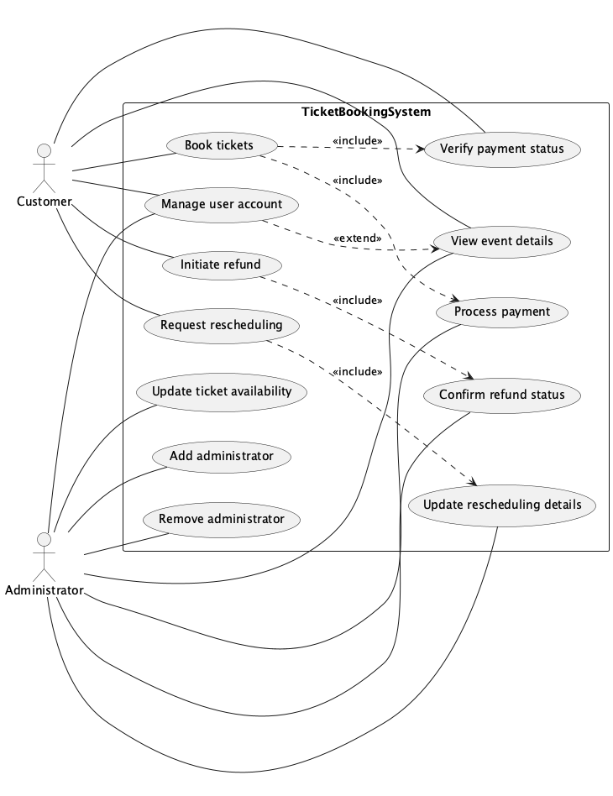

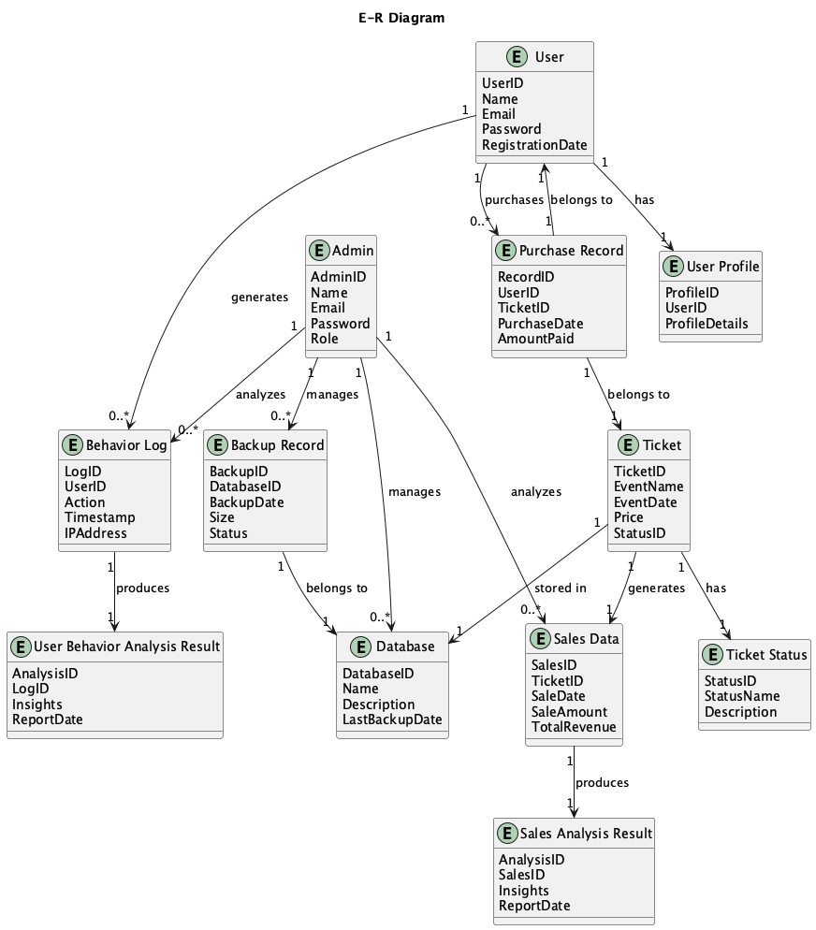

**System Operation and Maintenance with Third-Party Integration Subsystem**

**以下是按照你提供的格式为每个核心用例编写的至少两个功能需求：**

**1.1 Server Monitoring - Real-time Status Display Function**

**Function ID: FR-01**

**Description: Display real-time server status information on the monitoring dashboard.**

**Input: Server status data collected from monitoring tools.**

**Output: Real-time display of server CPU usage, memory usage, disk I/O, and other key metrics on the dashboard.**

**1.2 Server Monitoring - Historical Data Query Function**

**Function ID: FR-02**

**Description: Allow administrators to query historical server status data for analysis.**

**Input: Time range for historical data query.**

**Output: Historical server status data displayed in a readable format, such as charts or tables.**

**1.3 Network Traffic Analysis - Real-time Traffic Visualization Function**

**Function ID: FR-03**

**Description: Visualize real-time network traffic flow and usage on the monitoring dashboard.**

**Input: Real-time network traffic data.**

**Output: Real-time visualization of network traffic, including bandwidth usage, traffic sources, and destinations.**

**1.4 Network Traffic Analysis - Traffic Anomaly Detection Function**

**Function ID: FR-04**

**Description: Detect and alert on network traffic anomalies that may indicate issues or security threats.**

**Input: Real-time network traffic data and predefined anomaly thresholds.**

**Output: Alerts generated for detected anomalies, including details of the anomaly and affected network segments.**

**1.5 System Response Time Tracking - Real-time Response Time Display Function**

**Function ID: FR-05**

**Description: Display real-time system response times for key services and transactions.**

**Input: Real-time response time data collected from system monitoring tools.**

**Output: Real-time display of system response times on the monitoring dashboard.**

**1.6 System Response Time Tracking - Historical Response Time Analysis Function**

**Function ID: FR-06**

**Description: Allow administrators to analyze historical system response times to identify trends and issues.**

**Input: Time range for historical response time data query.**

**Output: Historical system response time data displayed in a readable format, such as charts or tables.**

**1.7 Performance Data Collection - Automated Data Collection Function**

**Function ID: FR-07**

**Description: Automatically collect performance data from various system components at regular intervals.**

**Input: Configuration settings for data collection frequency and components to monitor.**

**Output: Performance data collected and stored in a centralized database.**

**1.8 Performance Data Collection - Data Accuracy Verification Function**

**Function ID: FR-08**

**Description: Verify the accuracy of collected performance data to ensure reliability.**

**Input: Collected performance data and predefined accuracy checks.**

**Output: Validation results indicating whether the data is accurate or if there are discrepancies.**

**1.9 Firewall Configuration - Rule Creation Function**

**Function ID: FR-09**

**Description: Allow administrators to create new firewall rules to control network traffic.**

**Input: Parameters for the new firewall rule, such as source IP, destination IP, port, and protocol.**

**Output: New firewall rule created and applied to the firewall.**

**1.10 Firewall Configuration - Rule Modification Function**

**Function ID: FR-10**

**Description: Allow administrators to modify existing firewall rules as needed.**

**Input: Selection of the firewall rule to modify and new parameters.**

**Output: Modified firewall rule applied to the firewall with confirmation.**

**1.11 Intrusion Detection - Real-time Intrusion Alert Function**

**Function ID: FR-11**

**Description: Generate real-time alerts for detected intrusion attempts.**

**Input: Real-time network traffic and system activity data.**

**Output: Alerts generated for detected intrusions, including details of the intrusion attempt and affected systems.**

**1.12 Intrusion Detection - Intrusion Log Analysis Function**

**Function ID: FR-12**

**Description: Analyze intrusion logs to identify patterns and potential vulnerabilities.**

**Input: Intrusion logs collected over a specified time period.**

**Output: Analysis report highlighting patterns, potential vulnerabilities, and recommendations for mitigation.**

**1.13 Payment Request Processing - Secure Payment Processing Function**

**Function ID: FR-13**

**Description: Process payment requests securely using encryption and secure communication protocols.**

**Input: Payment request data, including payment amount, payment method, and user information.**

**Output: Payment processed securely with confirmation and transaction details logged.**

**1.14 Payment Request Processing - Payment Status Update Function**

**Function ID: FR-14**

**Description: Update the payment status in the system after processing a payment request.**

**Input: Payment request ID and processing result.**

**Output: Payment status updated in the system with confirmation and activity logged.**

**1.15 Bank Integration - Secure Connection Establishment Function**

**Function ID: FR-15**

**Description: Establish a secure connection with bank systems for payment processing.**

**Input: Bank system credentials and connection parameters.**

**Output: Secure connection established with the bank system, ready for payment transactions.**

**1.16 Bank Integration - Transaction Data Synchronization Function**

**Function ID: FR-16**

**Description: Synchronize transaction data with the bank system to ensure consistency.**

**Input: Transaction data from the system and bank system.**

**Output: Transaction data synchronized with the bank system, ensuring consistency and accuracy.**

**1.17 Payment Platform Integration - Secure Connection Establishment Function**

**Function ID: FR-17**

**Description: Establish a secure connection with third-party payment platforms for payment processing.**

**Input: Payment platform credentials and connection parameters.**

**Output: Secure connection established with the payment platform, ready for payment transactions.**

**1.18 Payment Platform Integration - Payment Method Support Function**

**Function ID: FR-18**

**Description: Support multiple payment methods through integration with payment platforms.**

**Input: User-selected payment method and payment request data.**

**Output: Payment processed using the selected payment method with confirmation and transaction details logged.**

**1.19 SMS Notification Sending - Real-time SMS Sending Function**

**Function ID: FR-19**

**Description: Send real-time SMS notifications to users for important events or reminders.**

**Input: User phone number and SMS content.**

**Output: SMS sent to the user with confirmation and activity logged.**

**1.20 SMS Notification Sending - Bulk SMS Sending Function**

**Function ID: FR-20**

**Description: Send bulk SMS notifications to multiple users for marketing or informational purposes.**

**Input: List of user phone numbers and SMS content.**

**Output: Bulk SMS sent to users with confirmation and activity logged.**

**1.21 Email Notification Sending - Real-time Email Sending Function**

**Function ID: FR-21**

**Description: Send real-time email notifications to users for important events or reminders.**

**Input: User email address and email content.**

**Output: Email sent to the user with confirmation and activity logged.**

**1.22 Email Notification Sending - Bulk Email Sending Function**

**Function ID: FR-22**

**Description: Send bulk email notifications to multiple users for marketing or informational purposes.**

**Input: List of user email addresses and email content.**

**Output: Bulk email sent to users with confirmation and activity logged.**

**1.23 Railway Bureau Data Integration - Real-time Data Synchronization Function**

**Function ID: FR-23**

**Description: Synchronize real-time railway bureau data with the system for accurate information.**

**Input: Railway bureau data and synchronization parameters.**

**Output: Real-time railway bureau data synchronized with the system, ensuring accuracy and consistency.**

**1.24 Railway Bureau Data Integration - Historical Data Query Function**

**Function ID: FR-24**

**Description: Allow administrators to query historical railway bureau data for analysis.**

**Input: Time range for historical data query.**

**Output: Historical railway bureau data displayed in a readable format, such as charts or tables.**

**1.25 Third-Party Application Integration - Secure Connection Establishment Function**

**Function ID: FR-25**

**Description: Establish a secure connection with third-party applications for data exchange and integration.**

**Input: Third-party application credentials and connection parameters.**

**Output: Secure connection established with the third-party application, ready for data exchange.**

**1.26 Third-Party Application Integration - Data Exchange Function**

**Function ID: FR-26**

**Description: Exchange data with third-party applications to enhance system functionality.**

**Input: Data to be exchanged and third-party application connection details.**

**Output: Data exchanged with the third-party application with confirmation and activity logged.**

**1.27 Administrator Access Control - User Authentication Function**

**Function ID: FR-27**

**Description: Authenticate administrators accessing the system to ensure security.**

**Input: Administrator credentials (username and password).**

**Output: Authentication result indicating whether access is granted or denied.**

**1.28 Administrator Access Control - Role-Based Access Control Function**

**Function ID: FR-28**

**Description: Implement role-based access control to restrict access based on administrator roles.**

**Input: Administrator role and requested action.**

**Output: Access granted or denied based on the administrator's role and permissions.**

**1.29 Server Monitoring - Alert Notification Function**

**Function ID: FR-29**

**Description: Send alert notifications to administrators when server status metrics exceed predefined thresholds.**

**Input: Server status metrics and predefined alert thresholds.**

**Output: Alert notifications sent via email, SMS, or other configured methods.**

**1.30 Server Monitoring - Customizable Metrics Function**

**Function ID: FR-30**

**Description: Allow administrators to customize which server metrics are monitored and displayed.**

**Input: Selection of server metrics to monitor.**

**Output: Customized monitoring dashboard displaying selected metrics.**

**1.31 Network Traffic Analysis - Traffic Pattern Analysis Function**

**Function ID: FR-31**

**Description: Analyze network traffic patterns to identify potential bottlenecks or security threats.**

**Input: Historical and real-time network traffic data.**

**Output: Analysis report highlighting traffic patterns and recommendations for optimization.**

**1.32 Network Traffic Analysis - Traffic Prioritization Function**

**Function ID: FR-32**

**Description: Prioritize network traffic based on predefined rules to ensure critical services have sufficient bandwidth.**

**Input: Traffic prioritization rules and network traffic data.**

**Output: Network traffic prioritized according to rules, with critical services receiving higher priority.**

**1.33 System Response Time Tracking - Response Time Threshold Alert Function**

**Function ID: FR-33**

**Description: Generate alerts when system response times exceed predefined thresholds.**

**Input: System response time data and predefined alert thresholds.**

**Output: Alerts sent to administrators when response times exceed thresholds.**

